**PROJECT REPORT ON**

**A Study on Adoption of and use of open AI in the modern world : A focus on Chatgpt**

**BATCH: 2023-25**

|  |  |
| --- | --- |
| **SUBMITTED BY: -** | **SUBMITTED TO: -** |
| **DIVYANSHU VERMA** | **PROF.PALLAVI BHARDWAJ** |



## ARMY INSTITUTE OF MANAGEMENT & TECHNOLOGY GREATER NOIDA, UP - 201310

**SUPERVISOR CERTIFICATE – FACULTY MENTOR**

### This is to certify that MR. Divyanshu Verma , a student of Masters of Business Administration 2024-26, Army institute of Management and Technology, Greater Noida has successfully completed his project under my supervision.

During this period, he worked on the project titled **“A Study on Adoption of and use of open AI in the modern world : A focus on Chatgpt”** in partial fulfillment for the award of degree of Masters of Business Administration from GGSIP University, Delhi.

### To the best of my knowledge the project work done by the candidate has not been submitted to any university for the award of any degree. His performance and conduct have been good.

|  |  |
| --- | --- |
|  | **(Signature)** |
| **Date: -** | **Faculty Mentor** |

**CERTIFICATE OF ORIGINALITY**

### I hereby declare that the work, which is being presented in this project entitled **“A Study on Adoption of and use of open AI in the modern world : A focus on Chatgpt”**, is an authentic record of my own work carried out by me under the supervision and guidance of Prof. Smita Gaurav project guide, Army Institute of Management and Technology, Greater Noida. This project was undertaken as a part of the minor project report as per the curriculum of GURU GOBIND SINGH INDRAPRASTHA UNIVERSITY, DELHI for the partial fulfillment of MBA from ARMY INSTITUTE OF MANAGEMENT AND TECHNOLOGY and have not submitted the matter embodied here in this project for the award of any other Degree.

**Student Name: -Divyanshu Verma Enrollment No:-03318419824**

# 

# ACKNOWLEDGEMENT

### I wish to show my sincere gratitude to all those who made this study possible. First of all, I am thankful to the helpful staff and the faculty of Army Institute of Management and Technology Greater Noida. One of the most important tasks in every good study is its critical evaluation and feedback which was performed by my faculty guide Prof. Smita Gourav.

I am very thankful to my faculty for investing his precious time to discuss and criticize this study and explain the meaning of different concepts and how to think when it comes to problem discussions and theoretical discussions. My sincere thanks go to my Institute, friends and family, who supported and encouraged me.

**Student Name:**

**Mr. Divyanshu Verma**

**AIMT Greater Noida**

# EXECUTIVE SUMMARY

ChatGPT as a language model, provides a wide range of capabilities for processing and creating human-like writing. The study examines various factors that can be influenced by ChatGPT, according to the people. The primary data is gathered from a sample of 107 respondents recording their insight on what level of satisfaction or dissatisfaction ChatGPT has in various fields like education, research, hospitals, learning, creativity, etc. Also, if they have used ChatGPT in those respective fields or not. The area where it was circulated was Delhi Greater and Noida. The secondary data was gathered through Shodhganga, Google articles, and other online sources (Research Gateway) for the literature review and to understand the research more thoroughly. The main finding of the research was that most use of ChatGPT is in the education sector. The research findings reflect the extent of ChatGPT awareness among people in various sectors. This knowledge can be used to assess the penetration and familiarity of ChatGPT across various industries. The technology has proven to be very effective in mimicking human responses and generating coherent and relevant text.

# TABLE OF CONTENTS

|  |  |
| --- | --- |
| Content | Page No. |
| Supervisor Certificate –Faculty mentor | (i) |
| Certificate of Originality | (ii) |
| Acknowledgement | (iii) |
| Executive Summary | (iv) |
| [Chapter 1– Introduction](https://d.docs.live.net/de3a8b4b14418ee7/chatGPT/Minor%20Word.docx#_TOC_250005) | 1-8 |
| Chapter 2 –Literature review | 9-12 |
| Chapter 3-Objective | 13 |
| [Chapter 4 -Research methodology](https://d.docs.live.net/de3a8b4b14418ee7/chatGPT/Minor%20Word.docx#_TOC_250004) | 14 |
| [Chapter 5 -Data analysis](https://d.docs.live.net/de3a8b4b14418ee7/chatGPT/Minor%20Word.docx#_TOC_250003) | 15-31 |
| Chapter 6 – Findings | 32 |
| Chapter 7 – Limitations | 33 |
| Chapter 8- Conclusion | 34 |
| [References](https://d.docs.live.net/de3a8b4b14418ee7/chatGPT/Minor%20Word.docx#_TOC_250002) | 35-36 |
| [Plagiarism report](https://d.docs.live.net/de3a8b4b14418ee7/chatGPT/Minor%20Word.docx#_TOC_250000) | 37 |

**CHAPTER 1**

**INTRODUCTION**

ChatGPT is an artificial intelligence (AI) chatbot created by OpenAI that was released in November 2022. It is based on OpenAI's GPT-3.5 and GPT-4 families of large language models (LLMs) and has been fine-tuned (a transfer learning method) utilizing both supervised and reinforcement learning approaches.

ChatGPT is versatile, even though its primary role is to resemble a human conversationalist. It can write and debug computer programs, write business pitches in the style of celebrity CEOs, compose music, teleplays, fairy tales, and student essays, answer test questions (sometimes at a level above the average human test-taker, depending on the test), write poetry and song lyrics, emulate a Linux system, simulate entire chat rooms, play games like tic-tac-toe, and simulate an ATM. The training material for it contains many pages and knowledge about internet phenomena and programming languages such as bulletin board systems and Python.

Unlike other chatbots, it remembers just a few earlier suggestions from the same session. Journalists assume that this will enable it to function as a personalized therapist. OpenAI announced in March 2023 that it would be introducing it plugin functionality. This covers both OpenAI plugins like online surfing and code interpretation, as well as external plugins from companies like Expedia, OpenTable, Zapier, Shopify, Slack, and Wolfram.

ChatGPT, as a language model, provides a wide range of capabilities for processing and creating human-like writing. However, it still has some drawbacks in its current version. One significant weakness is that it still suffers from context and common-sense thinking. While it can provide syntactically and grammatically accurate responses, it may not always produce clear or logical responses that make sense in the context of a discussion. Furthermore, because it is trained on enormous volumes of data that may contain unconscious prejudices, its replies may be biased. Finally, since it lacks the essential background knowledge or subject experience, it may fail to grasp and respond correctly to complicated or nuanced issues.

ChatGPT has its own set of difficulties that users may face. One of the most prevalent problems users have is the inability to communicate their thoughts and inquiries in a way the model can understand. It may also deliver irrelevant or useless replies on occasion, which can be annoying for users looking for accurate and helpful information. It may also have technical troubles from time to time, resulting in poor response times or disconnection from the server, which can be inconvenient for users. Continuous training and improvement, on the other hand, can assist to reduce these issues and improve the overall user experience.

ChatGPT's fundamental algorithm analyses and learns from massive volumes of data, allowing it to create replies that match human language patterns and syntax. As a result, it is an excellent tool for conversational applications in which users must speak with a virtual agent in a natural and understandable manner.

The structure of it is intended to create natural language text by processing input sequences using a transformer-based neural network. The model has already been trained on a huge corpus of text data and may be fine-tuned for specific purposes like chatbot answer creation.

The transformer architecture was presented in Vaswani et al. (2017)'s work "Attention is All You Need" and has since been a popular choice for natural language processing jobs. The transformer- based architecture is intended to process token sequences (words, sentences, and so on) and can manage long-range relationships.

ChatGPT has been pre-trained on a huge corpus of text data. Training the model on a task that does not need labeled data (unsupervised learning) is part of the pre-training process. Language modeling is generally used for this job, which entails predicting the next word in a sequence based on the preceding ones. It can learn to create coherent and natural-sounding language by pre- training on a huge corpus of text data.

It may be fine-tuned on a specific job that requires labeled data once it has been trained (supervised learning). It may be fine-tuned on a chatbot task, for example, where the aim is to create replies to user questions. The model's parameters are modified during fine-tuning to enhance performance on the given job.

The transformer design employs multi-head attention to allow the model to pay to various sections of the input sequence. Splitting the input sequence into numerous sub-sequences and conducting attention operations on each sub-sequence independently is what multi-head attention entails. This enables the model to learn many properties of the input sequence at the same time.

The transformer design employs positional encoding to deal with the sequential nature of natural language text. The process of adding position-specific information to the input sequence helps the model to grasp the order of the tokens in the sequence.

ChatGPT's output layer is a SoftMax layer that generates a probability distribution of probable next words over the vocabulary. The model creates text by randomly selecting a word from this distribution and inserting it as the next token in the sequence.

One of ChatGPT's primary features is its capacity to learn and improve over time. This is accomplished through an unsupervised learning process in which the model is fed enormous volumes of data without any explicit direction or supervision. It can discover patterns and trends in this data as it analyzes it, which it can then utilize to provide more accurate and relevant replies to user questions.

One of the most significant advantages of it is its ability to automate many regular activities and interactions, allowing human agents to focus on more complicated or high-value work. Businesses can benefit from considerable cost reductions as well as greater efficiency and production. A ChatGPT-powered chatbot, for example, may manage consumer enquiries and support requests around the clock without the need for human interaction. This can assist firms in providing better customer care and assistance while also decreasing the strain on support employees.

It also has an influence on today's environment by providing more personalized and engaging consumer interactions. It can enable a more conversational and natural contact with clients by creating human-like replies that match natural language patterns. This can aid in the development of trust and rapport with consumers, ultimately leading to increased levels of customer satisfaction and loyalty.

It is utilized in a variety of different applications outside customer care and assistance, such as virtual assistants and language translation. A virtual assistant powered by it, for example, may assist users with a variety of activities such as arranging appointments, making travel plans, and seeking information online. Meanwhile, it might be used by language translation tools to provide more accurate and natural-sounding translations of written or spoken content.

#### ChatGPT in Educational Sector:

ChatGPT may be utilized to provide students with personalized learning experiences. It can develop customized lesson plans, offer feedback on assignments, and answer questions in a method that is suited to each individual student by analyzing each student's learning patterns and needs. This has the potential to increase student involvement, motivation, and performance.

It can also assist pupils in learning new languages. It can deliver a more immersive and engaging language learning experience by producing natural-sounding replies in the target language. It may also provide students feedback on their pronunciation and grammar, allowing them to improve their language abilities more rapidly.

It may be utilized to give students on-demand instruction and support. Students who are struggling with a specific idea or task, for example, can ask it for assistance and receive personalized comments and support. This can assist to increase student achievement while also reducing instructor effort.

It can also assist students with impairments or other learning issues to gain access to education. For example, students who struggle in typical classroom settings or who want extra assistance can utilize it to get personalized learning resources and support.

It can help authors, painters, and other creative workers collaborate more effectively. it can assist to develop new and unique works of art and literature by giving a forum for exchanging ideas and comments.

Finally, it may be utilized to aid in educational research and analysis. It may, for example, analyze massive volumes of data to uncover patterns and trends in student performance, or it can provide natural language summaries of study findings.

There are various sectors where it has shown a great influence on people. They are as follows:

#### ChatGPT in Market-Business Sector:

It is becoming increasingly significant in marketing and product services as companies strive to give better client experiences while growing their bottom line. Businesses utilize ChatGPT- powered chatbots to provide 24/7 customer assistance, answer queries, and resolve issues. This can result in faster response times, more efficient assistance, and lower corporate expenses.

It may be used to provide personalized product and service suggestions based on a customer's interests, preferences, and behavior. This can lead to greater consumer happiness, sales, and brand loyalty. It can also increase the effectiveness of natural language search, making it easier for consumers to locate the items or services they need. This may result in a more positive user experience, more engagement, and higher conversion rates. It may provide content for websites, social media posts, and other marketing materials. Businesses may save time and costs while ensuring that the material is engaging and relevant to the target audience.

It can produce marketing material including product descriptions, social media postings, and email newsletters. Marketing teams may save time while still ensuring that the material is interesting and relevant to clients. It may also be used to collect consumer feedback and insights, which can then be utilized to guide product development and enhance overall customer experience. This can result in better products, more customer happiness, and a stronger brand reputation.

#### ChatGPT Influencing Creativity:

It is also having a substantial influence on creative writing and knowledge acquisition. It often answers inquiries on a wide range of topics, giving consumers rapid access to information and expertise. This is especially beneficial for students, researchers, and professionals that want speedy responses to specific concerns. It may be used to aid authors with their writing by generating ideas, developing characters, and refining their writing style. This may lead to more innovative and engaging writing, which is especially beneficial for authors with writer's block.

5

#### ChatGPT as a Nurse:

ChatGPT, as an artificial intelligence language model, has the potential to help healthcare institutions all around the world in several ways. It may be utilized to deliver remote medical consulting services to patients. Patients can explain their symptoms, and it can provide appropriate care or send them to a professional if necessary. This might be especially beneficial for persons who reside in distant places or have restricted access to healthcare.

It can also help medical researchers by analyzing massive amounts of data and finding patterns or connections. This might lead to discoveries in fields including illness detection, medication development, and treatment efficacy. It can also aid in the realm of mental health by offering support and counseling to people who are suffering from mental illnesses. It can provide a secure and confidential environment for people to express themselves and get emotional support. It can also give resources and recommendations to mental health experts if necessary.

It can help with medical education by offering information and answering questions about a wide range of medical issues. It can help medical students and healthcare professionals enhance their learning and remain up to date on the latest research and advancements in their industry. It can also assist healthcare practitioners in remotely monitoring patients. Patients with chronic diseases, for example, might utilize it to monitor their symptoms and communicate any changes or concerns to their healthcare physician. This might allow doctors to intervene early and avoid consequences.

Overall, it has the potential to transform the healthcare business by increasing access to treatment, providing patients with support and resources, and supporting healthcare practitioners in their job. It is crucial to stress, however, that it is not a replacement for human healthcare practitioners, but rather a tool to support and enhance their work.

#### ChatGPT Improving Job Satisfaction of Employees:

It may be utilized to give employees training and development materials. It can provide tailored learning paths depending on an employee's abilities, work duties, and career objectives. It may also enable rapid access to materials like training videos, articles, and podcasts to assist staff remain current with industry advancements. It may help employees plan their careers by giving advice on career routes, skill development, and employment prospects. It may assist employees in identifying their strengths and areas for development, as well as recommending training or development options to help them accomplish their professional objectives.

It may assist managers and staff in setting objectives and tracking progress toward those goals. It might provide employee feedback on their performance and recommend areas for improvement. It may also assist managers and employees in identifying training and development opportunities to close performance gaps. It can assist new staff in swiftly getting up to speed by offering onboarding and orientation materials. It can include details on the company's rules, culture, and processes. It may also answer frequent inquiries for new workers and help them as they transition into their new careers.

It may be used to promote employee engagement by offering a communication and feedback platform. It can allow employees to share feedback on corporate projects, make suggestions for changes, and ask questions. It may also give employee recognition and prizes, which can increase morale and motivation. It may help employees develop by offering tailored learning opportunities, career counseling, performance feedback, and support. It can assist employees in reaching their full potential and making a more productive contribution to their firm.

#### ChatGPT Enhancing Human Thinking Capabilities:

By giving access to knowledge, exposing individuals to multiple points of view, stimulating analysis and synthesis, encouraging problem-solving, and supporting learning and growth, it can enhance human critical thinking capacity. These elements can contribute to a better knowledge of challenges, better decision-making, and more effective problem-solving abilities. By providing tailored learning opportunities, it can aid in learning and growth. It can assist individuals in identifying areas for development and recommending training or development options to address such areas. It may also give feedback and assistance, promoting, advising, and growth.

ChatGPT has the ability to affect individuals' critical thinking skills in a variety of ways. It can offer access to a wealth of information from a variety of sources. This knowledge may contain a variety of viewpoints, thoughts, and ideas that can help an individual gain a better understanding of a subject. It may also give real-time updates on news and events, allowing users to keep informed and up to date.

It may expose people to many points of view and opinions on a given issue. This exposure might cause an individual's pre-existing views and biases to be challenged, leading to a better knowledge of the problem at hand. It may also help people comprehend the reasoning behind diverse points of view, which can foster critical thinking and informed decision-making.

It can help with sophisticated information processing and synthesis. It can assist individuals in seeing patterns and connections between various pieces of information, which can lead to a more in-depth knowledge of the problem. It can also assist users in determining the trustworthiness and dependability of sources, promoting critical thinking and discernment. By providing recommendations and answers to complicated situations, it can assist individuals in developing problem-solving abilities. It can motivate people to think creatively and beyond the box, fostering critical thinking and creativity. It can also assist individuals in breaking big problems down into smaller components, making them more manageable and easier to solve.

#### Importance of ChatGPT:

It has significant implications for the future of human-machine interaction. It has the potential to enhance communication and collaboration between humans and machines, leading to more efficient and effective processes.

Furthermore, it can be used to address various societal challenges such as language barriers, accessibility, and mental health. The technology can provide personalized support and assistance to individuals in need, improving their quality of life.

**CHAPTER 2 LITERATURE REVIEW**

ChatGPT can automatically produce anything that looks like human-written text. **Stephen Wolfram (Feb, 2022)** conducted research on how it accomplishes this and why it is effective. Research gave a rough outline of what’s going on inside it and then looked into why it can create what we may consider meaningful writing. The first thing to clarify is that ChatGPT's core goal is to create a "reasonable continuation" of any text that has been generated thus far. He used a more basic GPT-2 system, which has the benefit of being tiny enough to function on a desktop computer. He studied the coding method used by ChatGPT with the objective to understand it and find loopholes in its programming. He also tried to add features of his coding language “Wolfram” to it.

Another study has been performed by **Gary Marcus (Dec, 2022)** where he stated that systems like ChatGPT are incredibly entertaining and even startlingly human-sounding, but they are also untrustworthy and risk spreading disinformation. They are frequently true since language frequently replicates the world, but these systems do not genuinely reason about the world and how it works, thus the correctness of what they say is partially a matter of luck. He said, “Overall because the average rate of getting correct answers from ChatGPT is too low, the posting of answers created by ChatGPT is substantially harmful to the site and to users who are asking or looking for correct answers.”

Making language models larger does not automatically improve their ability to follow a user's intent **Jan Leike (Mar, 2023)**. In his research, it was demonstrated that fine-tuning using human input may be used to align language models with user intent on a wide range of activities. They collected a dataset of labeler examples of the required model behavior using supervised learning, starting with a set of labeler-written prompts and prompts provided using the OpenAI API. Despite the fact that Instruct GPT still made minor errors, their results demonstrated that fine-tuning using human feedback is a potential route for aligning language models with human intent.

Another study seeks to provide an overview of key terminologies linked to ChatGPT, an OpenAI public utility, and its underlying technology, Generative Pretrained Transformer (GPT). The interview covers the advantages of it, such as improved search and discovery, reference and information services, cataloging and metadata development, and content creation, as well as the ethical aspects that must be considered, such as privacy and bias. This paper describes GPT's history and technology, including its generative pre-trained transformer model, its capacity to do a wide range of language-based tasks, and how it employs this technology to act as a sophisticated chatbot. **Brady, Lund, and Ting Wang (2023** Concerns/potential leaps linked to it use were expressed in 58/60 (96.7%) records, with the most common being ethical issues such as bias, plagiarism, copyright issues, transparency issues, legal issues, lack of originality, incorrect responses, limited knowledge, and inaccurate citations. **Malik Sallam (Feb, 2023)** analyzed the Utility of it as an Example of Large Language Models in Healthcare Education, Research, and Practice, with a focus on a systematic review of Future Perspectives and Potential Limitations. Despite ChatGPT's promises, its adoption should be approached with utmost caution. He concluded that, as things stand, it does not qualify to be included as an author in scientific journals unless the ICMJE/COPE rules are changed and amended.

**A. Shaji George and A. S. Hovan George (Feb, 2023)** investigated a research topic titled “ChatGPT: AI's Impact on Several Business Sectors”, in which they examined current uses or cases of it in education, entertainment, finance, health, news, and production sectors, as well as possible future applications. They also talked about how to leverage the technology to provide more personalized content for users. After doing extensive research, they concluded that it offers features such as subject detection, mood detection, and sentiment analysis to assist users in better understanding their conversation partner. They also discussed some of the obstacles to AI development and how to overcome them.

Systematic reviews are in-depth examinations of the literature on a specific research subject. These evaluations are frequently regarded as the highest type of evidence in evidence-based medicine, and they constitute the primary technique for answering medical research issues. Complex Boolean queries are frequently used to retrieve studies for the review topic to build a high-quality systematic review. This is what **Shuai Wang, Harrison Scells, Bevan Koopman, and Guido Zuccon (Feb, 2023)** conducted their research on “Can ChatGPT Write a Good Boolean Query for Systematic Review Literature Search?”. They discovered that it is capable of generating queries that result in excellent search precision, albeit at the expense of a recall, after a series of lengthy trials using typical test collections for the task. Overall, our findings show that it can generate successful Boolean queries for systematic review literature searches.

Literature review articles are required to summarize relevant work on the chosen topic. Covering all linked studies, on the other hand, requires far too much time and effort. **Ömer Aydın and Enis Karaarslan (Dec, 2022)** questioned the employment of it in this process. To demonstrate the level of the OpenAI ChatGPT AI application, they developed a research review article. Abstracts of publications published in the previous three years (2020, 2021, and 2022) were retrieved from Google Scholar search results using the keyword "Digital twin in healthcare" and paraphrased using it. The results seem good; nevertheless, when examined with the Authenticate tool, the paraphrased parts had substantial matches. They came to the conclusion that the future academic publication procedure will involve less human work, allowing academics to focus on their studies.

**Jürgen Rudolph, Samson Tan, Shannon Tan (Jan,2023)** was the first to undertake a study on peer-reviewed academic journal papers to investigate it and its usefulness for higher education (particularly assessment, learning, and teaching). They concentrated on the implications of technology for higher education. They examined student-facing, teacher-facing, and system-facing applications, as well as possibilities and risks, in the context of current Artificial Intelligence in Education (AIEd) research. They finished the piece with advice for students, professors, and institutions of higher learning. Many of them concentrated on evaluation. They also emphasized ChatGPT's fundamental shift from a non-profit company to a commercial business model.

**Teo Susnjak (Dec,2022)** expressed worry about ChatGPT being used as a tool for academic cheating in online tests. According to the study, it is capable of displaying critical thinking abilities and creating a very realistic language with minimal input, posing a possible danger to the integrity of online assessments, particularly in tertiary education settings where such exams are becoming more common. More study is needed to properly comprehend the consequences of big language models such as it and to design techniques to prevent the possibility of cheating while utilizing these tools. It is critical for educators and institutions to be aware of the risk of it being used for cheating and to study countermeasures in order to keep online assessments fair and legitimate for all students.

After performing 30 theory-based and application-based ChatGPT tests, it was discovered that it has the potential to replace search engines since it offers students accurate and dependable feedback. **Samira Dishari, Marina Jovic, Koba Lomidze, and Mohammad Awad AlAfnan (Mar, 2023)** discovered that ChatGPT provides a venue for students to seek answers to theory- based questions and provide suggestions for application-based inquiries in terms of possibilities. It also provides a platform for teachers to incorporate technology into their classes and hold workshops to analyze and evaluate the generated replies. In terms of problems, the study discovered that if students utilize it unethically, it can lead to human unintelligence and unlearning. This may also pose a problem for teachers, since the usage of it impairs their capacity to discern between diligent and automation-dependent students on the one hand, and to assess learning results on the other. Surprisingly, this study discovered that it skillfully paraphrases regenerated replies in a way that similarity detection tools do not identify. Similarity detection software suppliers must improve their products to retain their efficiency and prevent such events from going undiscovered.

**Karthikeyan C.** researched on the topic “Pros and Cons of ChatGPT Implications in Education” and here he said that it can aid the learning community too if used protectively. Still, the victimization of it can be done by the superior intelligent brain of humans, who gave birth to this it with another version that makes the life of the learning community better to outwit or outclass ChatGPT, hence till then the era of it for good, better, or best supportive sixth sense of human

brain rather than a competitor to the professional identity that humans have come what may human brains have the capacity to bloom out for the better and evolve as invincible in the times to come.

## CHAPTER 3 OBJECTIVE

The following are the research objectives:

1. To analyze the satisfaction level of people using ChatGPT.
2. To examine the differences that ChatGPT can make in society according to people

## CHAPTER 4

## RESEARCH METHODOLOGY

* Type of data used: Both Primary and Secondary Data
* Sampling technique: Convenience Sampling.
* Sample size: 107 respondents.
* Sample area: New Delhi and Greater Noida.
* Data collection method was Google form which was distributed to school and college students, and employed people.
* The area where it was circulated was Delhi Greater and Noida.
* Secondary data was collected from Shodhganga, google articles and other online sources (Research Gateway).
* MS Excel was used to organize the collected data in tabular and pie charts.
* Network connection, technical knowledge, application sectors were the independent variables of the research.
* Effectiveness, usage, awareness was the dependent variable of the research.

## CHAPTER 5 DATA ANALYSIS

1. **People who have heard of ChatGPT before:**

Total :- 107

|  |  |  |  |  |
| --- | --- | --- | --- | --- |
| **Sr. no.** | **Response** | **percentage** | **Numbers of respondent** |  |
| **1** | **heard** | **89.7** | **96** |  |
| **2** | **Not heard** | **10.3** | **11** |  |
|  |  |  |  |  |

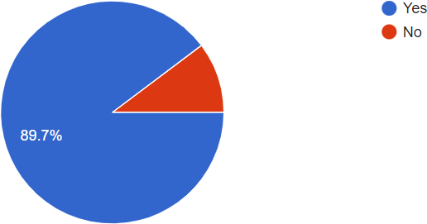

1. **Satisfaction level of using ChatGPT:**

Total :-107

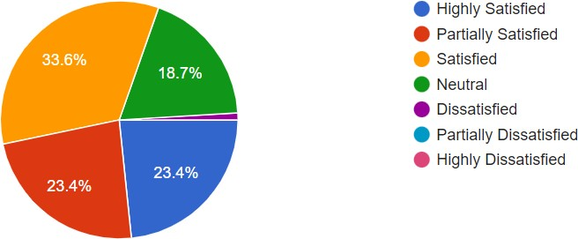

|  |  |  |  |
| --- | --- | --- | --- |
| Sr. no. | response | Percentage | Numbers of respondent |
| 1 | satisfied | 33.6 | 36 |
| 2 | Partially satisfied | 23.4 | 25 |
| 3 | Highly satisfied | 23.4 | 25 |
| 4 | neutral | 18.7 | 20 |
| 5 | dissatisfied | 0.93 | 1 |

3.Frequency of using ChatGPT: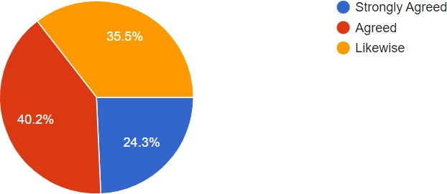

|  |  |  |  |
| --- | --- | --- | --- |
| Sr.no. | response | percentage | Numbers of respondent |
| 1 | High demand | 24.3 | 26 |
| 2 | regular | 40.2 | 43 |
| 3 | When they need it | 35.5 | 38 |

4.Chat GPT having Potential to Inspire Creativity in Humans:

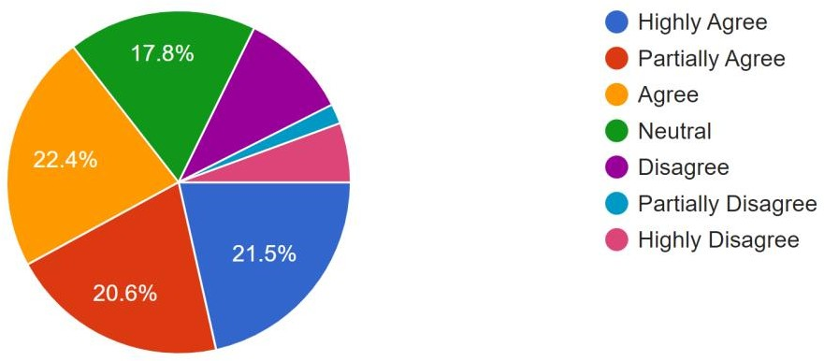

|  |  |  |  |
| --- | --- | --- | --- |
| Sr. no. | response | percentage | No. of respondent |
| 1 | inspire |  | 24 |
| 2 | Highly agree | 21.5 | 23 |
| 3 | Partially agree | 20.6 | 22 |
| 4 | Neutral | 17.8 | 19 |
| 5 | Disagree | 10 | 11 |
| 6 | Partially disagree | 1.86 | 2 |
| 7 | Highly disagree | 5.6 | 6 |

5.ChatGPT used to generate ideas or brainstorm:

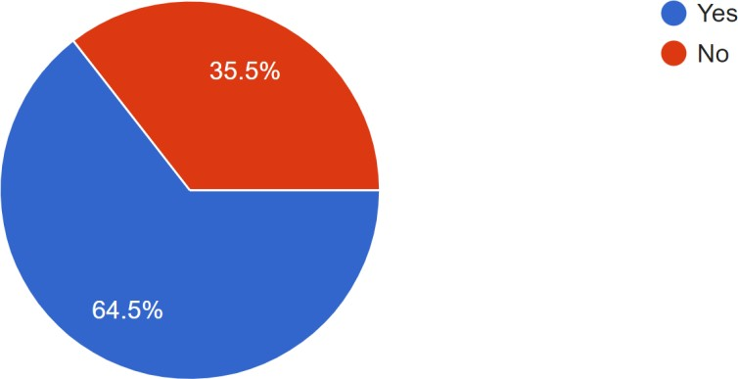

|  |  |  |  |
| --- | --- | --- | --- |
| Sr.no. | response | percentage | No. of respondent |
| 1 | yes | 64.5 | 69 |
| 2 | no | 35.5 | 38 |

6.ChatGPT having Potential to Improve Mental Health Outcomes:

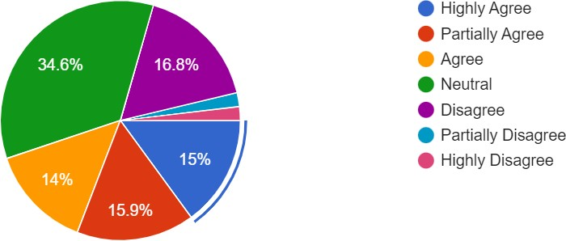

#### 

|  |  |  |  |
| --- | --- | --- | --- |
| Sr.no. | response | percentage | No. of respondent |
| 1 | Highly agree | 15 | 16 |
| 2 | Partially agree | 15.9 | 17 |
| 3 | Agree | 14 | 15 |
| 4 | Neutral | 34.6 | 37 |
| 5 | Disagree | 16.8 | 18 |
| 6 | Partial disagree | 1.86 | 2 |
| 7 | Highly disagree | 1.86 | 2 |

#### 

|  |  |  |  |
| --- | --- | --- | --- |
| **Sr.no.** | **response** | **percentage** | **respondent** |
| **1** | **yes** | **52** | **48.6** |
| **2** | **no** | **55** | **51.4** |

8.ChatGPT having potential to improve access to education:

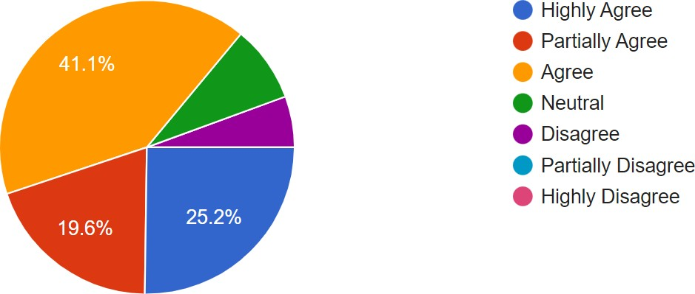

|  |  |  |  |
| --- | --- | --- | --- |
| Sr.no. | Response | percentage | Respondent |
| 1 | Agree | 41.1 | 44 |
| 2 | Partially agree | 19.62 | 21 |
| 3 | Highly agree | 25.2 | 27 |
| 4 | Neutral | 8.41 | 9 |
| 5 | Disagree | 5.60 | 6 |

9.ChatGPT used for research purpose:

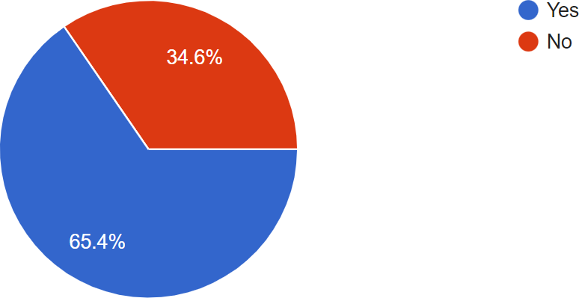

|  |  |  |  |
| --- | --- | --- | --- |
| Sr.no. | response | percentage | Respondent |
| 1 | Yes | 65.4 | 70 |
| 2 | No | 34.6 | 37 |

10.ChatGPT having potential to revolutionize the field of research:

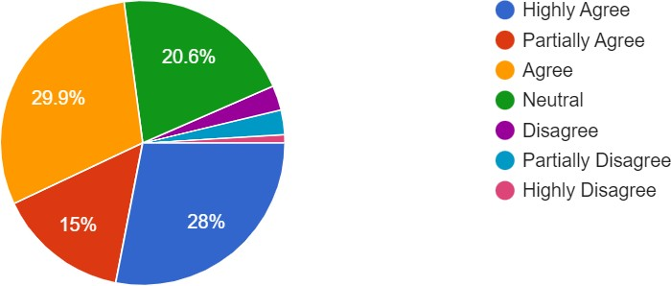

|  |  |  |  |
| --- | --- | --- | --- |
| Sr. no. | Response | Percentage | Respondent |
| 1 | Highly agree | 28 | 30 |
| 2 | Partially agree | 15 | 16 |
| 3 | Agree | 29.9 | 32 |
| 4 | Neutral | 20.6 | 22 |
| 5 | Disagree | 2.8 | 3 |
| 6 | Partially disagree | 2.8 | 3 |
| 7 | Highly disagree | 0.93 | 1 |

11.ChatGPT used to edit and write documents:

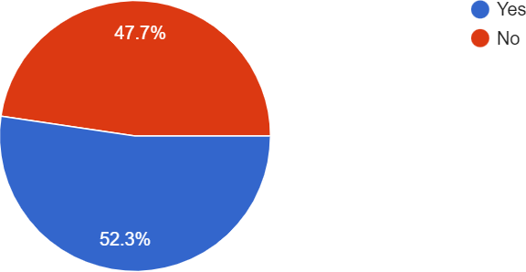

|  |  |  |  |
| --- | --- | --- | --- |
| Sr.no. | Response | Percentage | Respondent |
| 1 | YES | 52.3 | 56 |
| 2 | NO | 47.7 | 51 |

12.ChatGPT having potential to contribute to advancements in natural language processing:

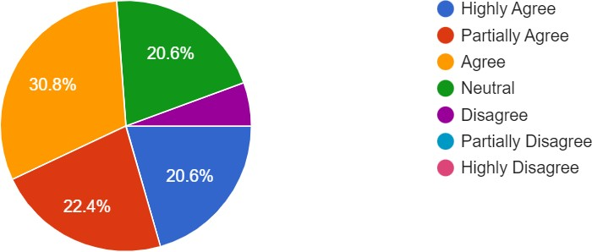

|  |  |  |  |
| --- | --- | --- | --- |
| Sr.no. | Response | Percentage | Respondent |
| 1 | Agree | 30.8 | 33 |
| 2 | Partially agree | 22.4 | 24 |
| 3 | Highly agree | 20.6 | 22 |
| 4 | Neutral | 20.6 | 22 |
| 5 | Disagree | 5.60 | 6 |

13.ChatGPT used for professional development:

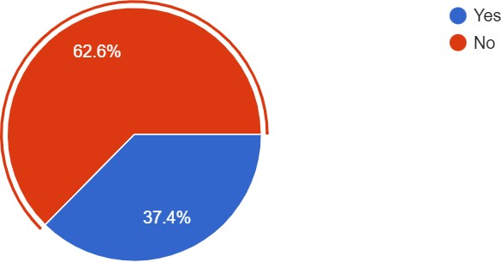

|  |  |  |  |
| --- | --- | --- | --- |
| Sr.no. | Response | Percentage | Respondent |
| 1 | Yes | 37.4 | 40 |
| 2 | No | 62.6 | 67 |

14.ChatGPT used to find products or services to buy:

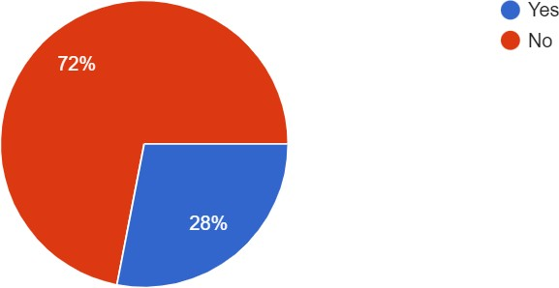

|  |  |  |  |
| --- | --- | --- | --- |
| Sr.no. | Response | Percentage | Respondent |
| 1 | Yes | 28 | 30 |
| 2 | No | 72 | 77 |

15.ChatGPT used to receive personalized recommendations:

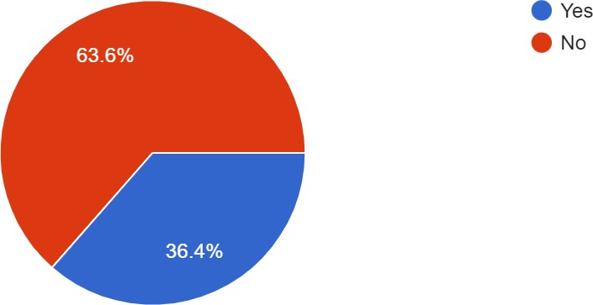

|  |  |  |  |
| --- | --- | --- | --- |
| Sr.no. | Response | Percentage | Respondent |
| 1 | Yes | 36.4 | 39 |
| 2 | No | 63.6 | 68 |

16.ChatGPT having potential to contribute to replace human customer service representatives or educators in the future:

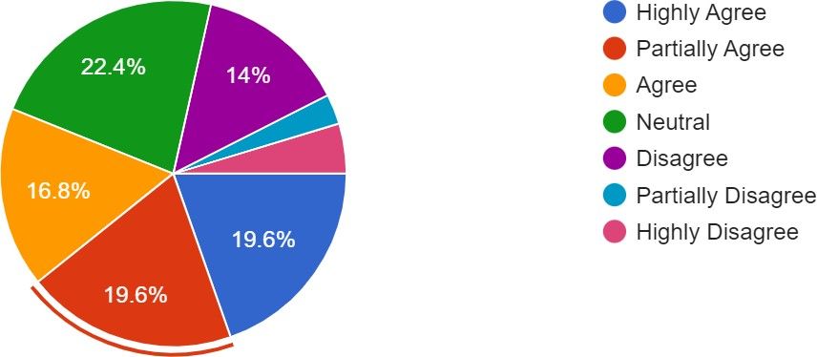

|  |  |  |  |
| --- | --- | --- | --- |
| Sr.no. | Response | Percentage | Respondent |
| 1 | Highly agree | 19.6 | 21 |
| 2 | Partially agree | 19.6 | 21 |
| 3 | Agree | 16.8 | 18 |
| 4 | Neutral | 22.4 | 24 |
| 5 | Disagree | 14 | 15 |
| 6 | Partially disagree | 2.8 | 3 |
| 7 | Highly disagree | 4.67 | 5 |

17.ChatGPT used to get information about news or current events:

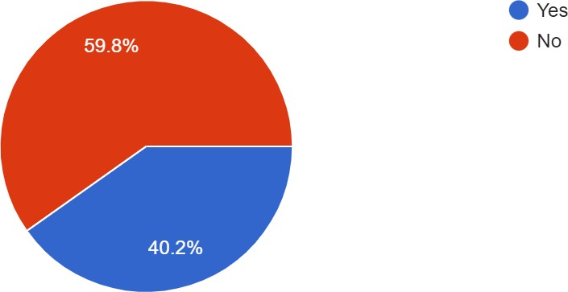

|  |  |  |  |
| --- | --- | --- | --- |
| Sr.no. | Response | Percentage | Respondent |
| 1 | Yes | 40.2 | 43 |
| 2 | No | 59.8 | 64 |

18.ChatGPT having potential to contribute to contribute to ethical concerns, such as privacy and security:

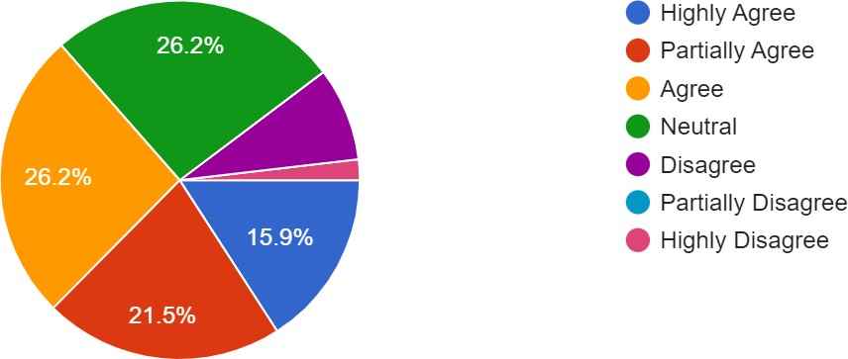

|  |  |  |  |
| --- | --- | --- | --- |
| Sr.no. | Response | Percentage | Respondent |
| 1 | Agree | 26.2 | 28 |
| 2 | Partially agree | 21.49 | 23 |
| 3 | Highly agree | 15.9 | 17 |
| 4 | Neutral | 26.2 | 28 |
| 5 | Disagree | 8.4 | 9 |
| 6 | Highly disagree | 1.86 | 2 |

19.ChatGPT improving customer service:

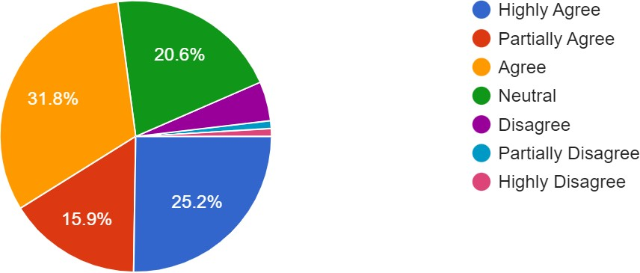

|  |  |  |  |
| --- | --- | --- | --- |
| Sr.no. | Response | Percentage | Respondent |
| 1 | Agree | 31.8 | 34 |
| 2 | Partially agree | 15.9 | 17 |
| 3 | Highly agree | 25.2 | 27 |
| 4 | Neutral | 20.6 | 22 |
| 5 | Disagree | 4.67 | 5 |
| 6 | Partially disagree | 0.93 | 1 |
| 7 | Highly disagree | 0.93 | 1 |

20.ChatGPT having potential to make seeking advice or guidance more accessible:

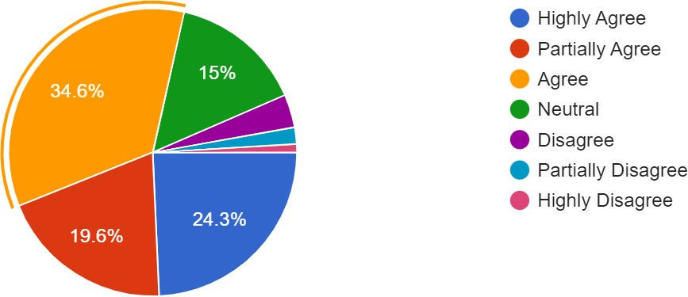

|  |  |  |  |
| --- | --- | --- | --- |
| Sr.no. | Response | Percentage | Respondent |
| 1 |  |  |  |
| 2 |  |  |  |
| 3 |  |  |  |

21.ChatGPT having potential to create new job opportunities:

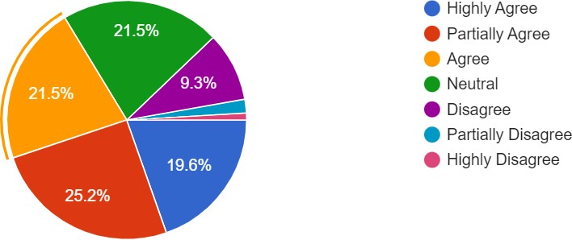

|  |  |  |  |
| --- | --- | --- | --- |
| Sr.no. | Response | Percentage | Respondent |
| 1 | Highly agree | 19.6 | 21 |
| 2 | Partially agree | 25.2 | 27 |
| 3 | Agree | 21.5 | 23 |
| 4 | Neutral | 21.5 | 23 |
| 5 | Disagree | 9.3 | 10 |
| 6 | Partially disagree | 1.86 | 2 |
| 7 | Highly disagree | 0.93 | 1 |

22.ChatGPT having potential to create more personalized and engaging online experiences for users:

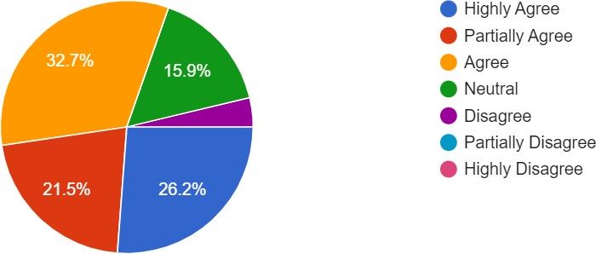

|  |  |  |  |
| --- | --- | --- | --- |
| Sr.no. | Response | Percentage | Respondent |
| 1 | Agree | 32.7 | 35 |
| 2 | Partially agree | 26.2 | 23 |
| 3 | Highly agree | 21.5 | 28 |
| 4 | Neutral | 15.9 | 17 |
| 5 | Disagree | 3.73 | 4 |

23.ChatGPT used for financial purposes, such as to manage money or invest:

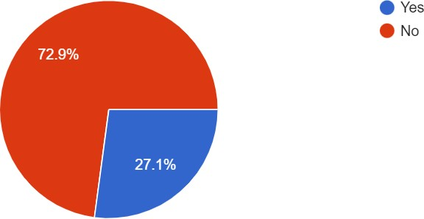

|  |  |  |  |
| --- | --- | --- | --- |
| Sr.no. | Response | Percentage | Respondent |
| 1 | Yes | 27.1 | 29 |
| 2 | No | 72.9 | 78 |

24.ChatGPT having potential to aid in financial decision making:

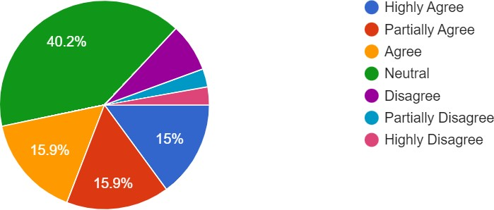

|  |  |  |  |
| --- | --- | --- | --- |
| Sr.no. | Response | Percentage | Respondent |
| 1 | Agree | 15.9 | 17 |
| 2 | Partially agree | 15.9 | 17 |
| 3 | Highly agree | 15 | 18 |
| 4 | Neutral | 40.2 | 43 |
| 5 | Disagree | 7.47 | 8 |
| 6 | Partially disagree | 2.80 | 3 |
| 7 | Highly disagree | 2.80 | 3 |

25.ChatGPT having potential to make travel planning more accessible:

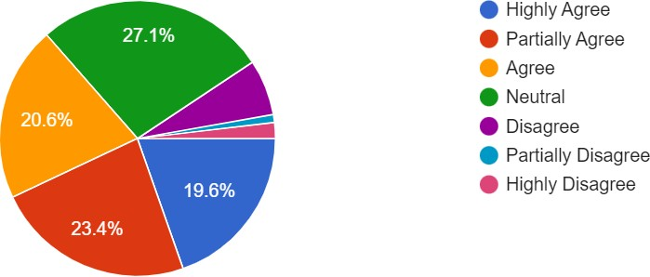

|  |  |  |  |
| --- | --- | --- | --- |
| Sr.no. | Response | Percentage | Respondent |
| 1 | Agree | 20.6 | 22 |
| 2 | Partially agree | 23.4 | 25 |
| 3 | Highly agree | 19.6 | 21 |
| 4 | Neutral | 27.1 | 29 |
| 5 | Disagree | 6.54 | 7 |
| 6 | Partially disagree | 0.93 | 1 |
| 7 | Highly disagree | 1.86 | 2 |

26.ChatGPT having potential to aid in career advancement:

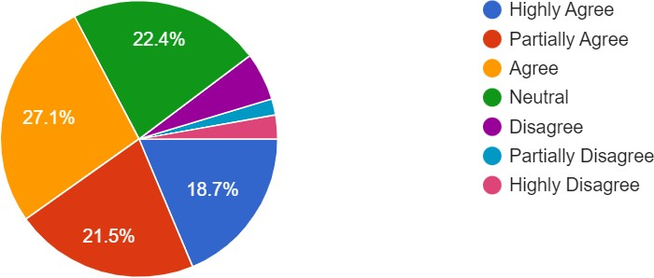

|  |  |  |  |
| --- | --- | --- | --- |
| Sr.no. | Response | Percentage | Respondent |
| 1 | Agree | 27.1 | 29 |
| 2 | Partially agree | 21.5 | 23 |
| 3 | Highly agree | 18.7 | 20 |
| 4 | Neutral | 22.4 | 24 |
| 5 | Disagree | 5.6 | 6 |
| 6 | Partially disagree | 1.86 | 2 |
| 7 | Highly disagree | 2.80 | 3 |

27.ChatGPT used to generate content:

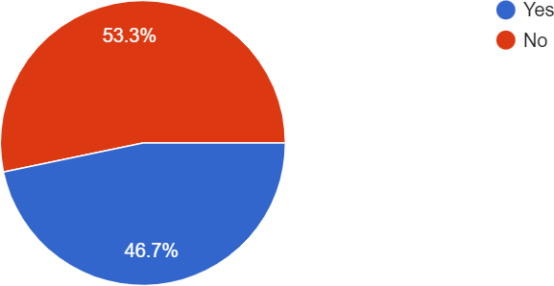

|  |  |  |  |
| --- | --- | --- | --- |
| Sr.no. | Response | Percentage | Respondent |
| 1 | Yes | 46.7 | 50 |
| 2 | No | 53.3 | 57 |

28.ChatGPT having indistinguishable conversation from a human:

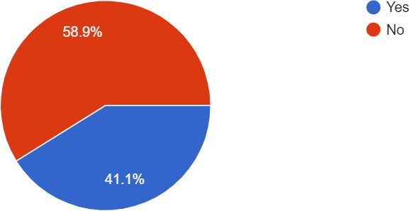

|  |  |  |  |
| --- | --- | --- | --- |
| Sr.no. | Response | Percentage | Respondent |
| 1 | Yes | 41.1 | 44 |
| 2 | No | 58.9 | 63 |

29.ChatGPT felt difficulty in understanding their queries or providing relevant responses:

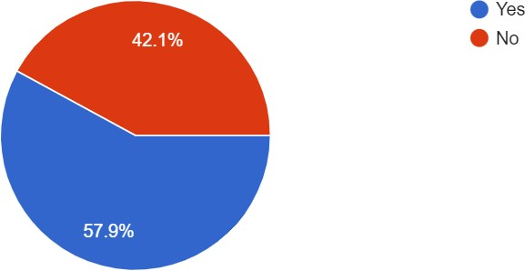

|  |  |  |  |
| --- | --- | --- | --- |
| Sr.no. | Response | Percentage | Respondent |
| 1 | Yes | 57.9 | 62 |
| 2 | No | 42.1 | 45 |

30.ChatGPT having potential to be used to reduce the effects of information overload:

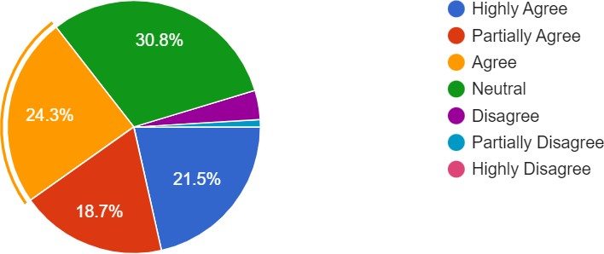

|  |  |  |  |
| --- | --- | --- | --- |
| Sr.no. | Response | Percentage | Respondent |
| 1 | Agree | 24.3 | 26 |
| 2 | Partially agree | 18.7 | 20 |
| 3 | Highly agree | 21.5 | 23 |
| 4 | Neutral | 30.8 | 33 |
| 5 | disagree | 3.73 | 4 |

31.People having negative experience while using ChatGPT:

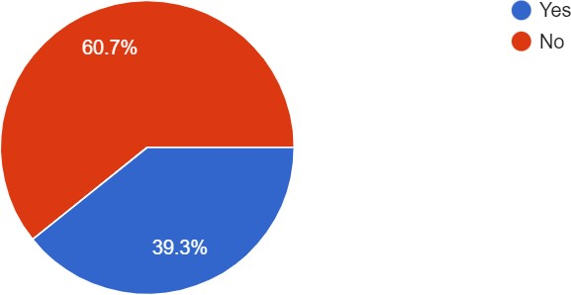

#### 

|  |  |  |  |
| --- | --- | --- | --- |
| Sr.no. | Response | Percentage | Respondent |
| 1 | Yes | 39.3 | 42 |
| 2 | No | 60.7 | 65 |

## CHAPTER 6 FINDINGS

* In the study, 32.7% are male, while 67.3% of respondents are female.
* 8.4% of the respondents are the age below 14, 42.1% of respondents are between 14 to 19, 29% between 19 to 24, and 21.5% of respondents are above 25.
* 29.9% of the respondents are studying in schools, 39.3% are doing graduation, 28% are doing postgraduate, 5.6% of the respondents are PhD holders.
* The research findings reflect the extent of ChatGPT awareness among people in various sectors. This knowledge can be used to assess the penetration and familiarity of ChatGPT across various industries.
* The study collects the perspectives of persons who do not use ChatGPT in numerous professions. Understanding their viewpoints might provide insights into the challenges, concerns, or reasons for ChatGPT's non-adoption, which may aid in addressing these difficulties and broadening its acceptance.

## CHAPTER 7 LIMITATIONS

* Because it is a relatively new issue, having been launched in November 2022, there may be limited literature reviews on this specific subject accessible at the time of the research study.
* Within a limited time period a lot of information had to be collected. The research could not be done in more detailing due to scheduling constraints.
* AI technologies, such as ChatGPT, are rapidly evolving, therefore findings became outdated quickly as newer models or techniques emerged.
* Artificial intelligence and chatbot research involve ethical considerations, such as privacy, data security, and possible prejudice. These factors formed a stumbling block throughout the research.
* One significant disadvantage is the model's tendency to create biased or offensive replies, particularly when trained on skewed data. This can have negative implications and weaken faith in technology.
* Another drawback is a lack of contextual awareness and common sense. ChatGPT can create intelligible replies, but they may not always be meaningful or relevant to the discourse. Users should use caution while using ChatGPT for important work.

## CHAPTER 8

**SUGGESTIONS**

Individuals who use ChatGPT should be mindful of the technology's limitations and inherent biases. Before acting on the responses generated by it, users should double- check their accuracy and relevancy.

Furthermore, users should think about the ethical consequences of using ChatGPT, especially in sensitive fields like healthcare and finance. Responsible technology use can help to ensure that it has a good impact on society.

Ignore the model's tendency to create biased or offensive replies, particularly when trained on skewed data.

Beware of the hacking and security issues off privacy, and data security.

## CHAPTER-9

**CONCLUSION**

This study contributes to assessing the knowledge and impact of ChatGPT across various sectors by investigating the perspectives of both users and non-users. These insights can help guide the development and application of it in the modern environment.

The research findings reflect the extent of its awareness among people in various sectors. This knowledge can be used to assess the penetration and familiarity of it across various industries.

The study delves into the viewpoints of persons who actively utilize it in various industries. These perspectives shed light on the advantages, disadvantages, and overall experiences of utilizing it, providing essential feedback for future enhancements and applications.

The study collects the perspectives of persons who do not use it in numerous professions. Understanding their viewpoints might provide insights into the challenges, concerns, or reasons for ChatGPT's non-adoption, which may aid in addressing these difficulties and broadening its acceptance.

**REFERENCES**

1. Stephen Wolfram (Feb, 2022). “What Is ChatGPT, and How Does It Work?” [Enleaf] (12 Dec. 2022)
2. Gary Marcus (Dec, 2022). “AI Platforms like ChatGPT Are Easy to Use but Also Potentially Dangerous” [Scientific American]
3. Jan Leike (Mar, 2023). “Training language models to follow instructions with human feedback” [Current affiliations: AA: Anthropic; PC: Alignment Research Center.]
4. Brady, Lund, and Ting Wang (2023). “Chatting about ChatGPT: How May AI and GPT Impact Academia and Libraries?” [Library Hi Tech News]
5. Malik Sallam (Feb, 2023). “ChatGPT Utility in Healthcare Education, Research, and Practice: Systematic Review on the Promising Perspectives and Valid Concerns.” [Healthcare 2023] (Received: 20 February 2023, revised: 17 March 2023, accepted: 17 March 2023, Published: 19 March 2023)
6. A. Shaji George and A. S. Hovan George (Feb, 2023). “A Review of ChatGPT AI's Impact on Several Business Sectors” [Partners Universal International Innovation Journal]
7. Shuai Wang, Harrison Scells, Bevan Koopman, and Guido Zuccon (Feb, 2023). “Can ChatGPT Write a Good Boolean Query for Systematic Review Literature Search?” [DOI Foundation]
8. Ömer Aydın and Enis Karaarslan (Dec, 2022). “OpenAI ChatGPT Generated Literature Review: Digital Twin in Healthcare” [Emerging Computer Technologies 2]
9. Jürgen Rudolph, Samson Tan, Shannon Tan (Jan,2023). “ChatGPT: Bullshit spewer or the end of traditional assessments in higher education?” [Journal of Applied Learning & Teaching]
10. Teo Susnjak (Dec,2022). “ChatGPT: The End of Online Exam Integrity?” [ResearchGate]
11. Samira Dishari, Marina Jovic, Koba Lomidze, and Mohammad Awad AlAfnan (Mar, 2023). “ChatGPT as an Educational Tool: Opportunities, Challenges, and Recommendations for Communication, Business Writing, and Composition Courses” [Journal of Artificial Intelligence and Technology] (Received 30 January 2023; Revised 02 March 2023; Accepted 02 March 2023; Published online 06 March 2023)

#### 